Drug Development Process for Biologics: Regulatory Expectations

Posted 22 January 2020 | By [Zain Chughtai](https://www.raps.org/news-and-articles/news-articles?author=c552c85f-f7db-4f25-ab09-0c39e5452427)

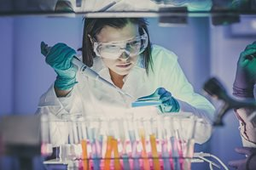This article discusses various elements involved in “upstream” and “downstream” manufacturing processes for biologic drug development and the importance of their unification. The author elaborates on the complexity and sensitivities inherent in biologics and emphasizes safety considerations. Regulatory expectations for biologics development and approval are highlighted. This article relates specifically to the EU regulatory environment.  
   
**Introduction**  
   
The development of biologics, drugs made from biological sources, is a complex, multi-faceted process. In recent decades, the process of developing biologics has become more efficient through scientific and technological advances. As a result, stringent regulations are in effect to ensure biologics being developed are of high quality, safety and efficacy for their proposed indication. This is determined using data generated across the product’s lifecycle relating to the product itself, as well as development and manufacturing processes.  
   
In many ways, biologics are not a new phenomenon. Natural products have been used to treat ailments for millennia. Initially, herbs were used, a practice still prevalent throughout Asia and has spread to Western societies through migration.1 The Chinese have relied on herbal remedies since before 3500 BC, and religious scriptures, including the Quran and the Vedas, also mention using natural sources, including turmeric, honey and cumin seeds, back to 5000BC.2 The active components within these substances make them beneficial for medicinal purposes. An example for using natural sources for medicinal purposes is the Rauwolfia evergreen, which contains the active component reserpine, proven to effectively reduce systolic blood pressure to the same extent as other antihypertensive drugs.3 Until the 20th century, scientific and technological limitations have prevented the isolation of active components. However, advancements in science and technology have made possible component identification, isolation and mass production.  
   
Biologics are drugs produced from large molecule biological sources, such as animal cells.4 Examples of currently used biologics include the use of trastuzumab for breast cancer or infliximab for the treatment of rheumatoid arthritis.  
   
These medications have been made possible through recombinant DNA technology, which allows genetically modified DNA to be artificially introduced into cells and “upscaled” to produce the Protein of Interest (PoI), which are commonly monoclonal antibodies (mAbs). Once harvested, these proteins are purified to remove product and process impurities. The two distinct parts of the process are called “upstream” and “downstream” processing and are generally identified as separate processes. **Figure 1** shows the upstream process steps are outlined in red and downstream process steps in green.5   
   
**Figure  1. Overview of the Drug Development Process for Biologics  
  
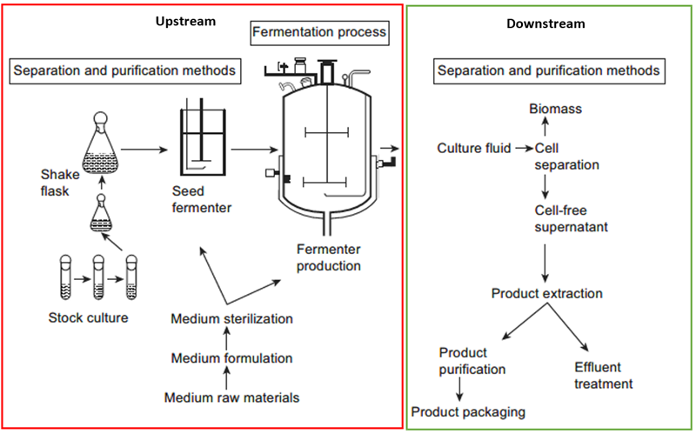**  
   
The processes in isolation are comparable to extraction of oil and refining of petroleum. However, because of the complexity and sensitivity of biologics, specific regulatory guidelines are available to facilitate safe development, use and marketing of these drugs. These guidelines focus on process characterisation and verification and are crucial to safeguarding patients by ensuring the API is safe and manufactured as intended. Guidelines focus on providing information to guide pharmaceutical organisations on key documentation and data required to demonstrate quality, safety and efficacy for a Market Authorization Application (MAA) in the European regulatory environment. Scientific advice should be sought prior to submission to better align with the regulatory authority’s expectations. Deviations from these guidelines require justification in order to mitigate delays in the approval process. For biologics, guidelines are provided for the active substance and the finished product. Guidelines are relevant for all stages of drug development, from CMC, to clinical development, and should be consulted when drafting an MAA.  
   
A significant quality guideline, for example, is ICH Q5B.6 This guideline highlights the importance of characterising the expression vector and the final purified protein. It requires the provision of rationale for the proposed expression vector as well as confirmation that the correct nucleotide sequence has been incorporated into the cell. It further states information on amplification, clone selection and cell banking systems is also required. Another example of an important guideline is EMA/CHMP/BWP/187338/2014, which describes data requirements for process characterisation and validation for manufacturing active substances.7 This is important as it displays to the regulatory body, that the pharmaceutical organization has knowledge of the product and its manufacturing process. It is important to be deemed as competent by the regulatory authority to convince them the process is lean and efficient, and the product will be of excellent quality and efficacy.  
   
**Upstream Processing**  
   
Upstream processing involves activities leading to the production of crude fermentation products which contain the PoI while controlling critical conditions to ensure a high yield without compromising product quality. Key upstream processes include media and cell line development, inoculation from a Working Cell Bank (WCB), seed manufacture, upscaling and harvesting the crude product from fermentation vessels. In recent years, the yield of protein expressed as “g protein per litre of fermenter liquid” has increased dramatically, enabling higher yields with smaller fermenter volumes. This has resulted in improved efficiency by nearly two orders of magnitude over recent decades. This can be attributed to increasing availability of genomic and transcriptomic resources as well as advances in genome technology.8  
   
An expression vector containing the Gene of Interest (GoI) that expresses the PoI is constructed to incorporate human genes into a host animal cell, enabling the production of fully humanized PoIs. An expression vector is a DNA construct which has been genetically modified to include the DNA sequence corresponding to the GoI to be expressed, as well as regulatory sequences to carefully control the expression of the GoI. In mAbs, the expression vector is stably transfected to incorporate the GoI into the vector genome to ensure future generations of the transfected cell will produce the PoI by clonal expansion. If suitable, a master cell bank is created from the selected clone, which is further used to create a working cell bank from which the production seed is grown.  
  
Cells are initially grown in shake flasks to reach predefined confluency and viability, typically measured by Optical Density (OD) before seeding in production bioreactors. This is to ensure titer and product quality expectations are met and also allows assessment of the performance and reproducibility of the process. Samples of cells are taken at regular intervals during the fermentation process to assess quality at different timepoints. This allows constant monitoring of cells in comparison to the originator. Modern bioreactors continuously control and monitor conditions, including temperature, dissolved gases and stirring speeds. Samples are then analyzed by HPLC to ensure the PoI is being produced in sufficient quantities. At the end of fermentation, the cells are harvested, which involves separating cellular biomass and debris from the desired product. As mammalian cells secrete synthesised proteins extracellularly, filtration using microporous membranes is conducted to prevent cell debris and large biomass fragments being collected. For prokaryotic cells, those which do not contain a distinct nucleus bound by a nuclear envelope,9 such as bacterial and plant cells, the harvest process varies depending on where the PoI is being secreted. Once filtered, the product is referred to as a Clarified Cell Culture Fluid (CCCF).  
   
The isolation of the human insulin gene and its expression is described using E.coli.10 This shows how other cell types may be used for drug development depending on the extent of Post Translational Modifications (PTMs) required. **Figure 2** illustrates the recombinant DNA principle. As illustrated, the gene which expresses the PoI is incorporated into a plasmid using enzymatic processes.11 Once incorporated, the expression vector is called a recombinant plasmid due to the genetic recombination. The vector is then transfected into the cells where the PoI is expressed in a stable, functional form due to the cellular environment being ideal for protein synthesis.12  
   
**Figure 2. Recombinant DNA Used to Synthesise Desired Protein of Interest in Bacterial Cells  
  
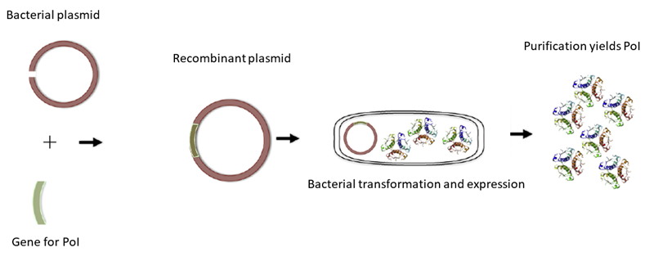**  
   
Although insect, plant and bacterial cells can be used to produce biologics, mammalian Chinese Hamster Ovary (CHO) cells are generally preferred for manufacturing drugs for humans. The ability of CHO cells to produce high yields, facilitate protein folding and extent of PTMs make them ideal for human biologic drug manufacture. PTMs are controlled by conditions to which cells are exposed and cannot be coded genetically. Immunogenicity can lead to adverse events for patients, and can also reduce efficacy of the drug by creating anti-drug antibodies which can inhibit the drug’s activation pathways.13 Additionally, CHO cells have been developed for decades and face less scrutiny from regulatory bodies from a development perspective and therefore are more likely to face regulatory approval.  
   
**Downstream Processing**  
   
After clarification and concentration of the product using Protein A (PrA) HPLC, viral inactivation is conducted. This inactivates any adventitious product and process viruses. It is a crucial step for avoiding transfer of viruses from drug to patients and, typically, uses low pH treatment followed by nano-filtration. The product is filtered using nano-membranes with pore sizes between 15 and 40 nanometers (a nanometer is 1 billionth of a meter) which separate the viruses from drug substance by size exclusion.14 After this step, further chromatography steps are conducted to separate any impurities by their chemical properties.  
   
After viral inactivation, it is important to remove process and product impurities. Generally, there are three steps in the downstream process:

* capture
* purification/polishing
* formulation and final fill

The first step is PrA chromatography, an affinity chromatography method illustrated in **Figure 3**.15 Affinity binding can be applied to protein A and ion exchange chromatography. The type of chromatography is determined by the characteristics of the stationary phase which could be Protein A resin or of cationic/anionic nature depending on the type of separation required.  
   
**Figure 3. Illustration of Affinity Binding  
  
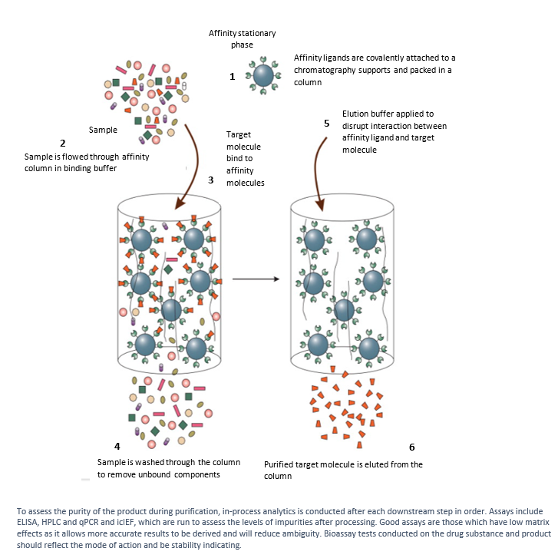**  
   
PrA resin is renowned for its high selectivity to IgG-type antibodies, high flow rate and capacity.16 It binds the IgGs from the clarified fermentation broth, allowing impurities, such as HCP and HCDNA, to flush through to waste. These are considered impurities due to their influence of immunogenicity within patients. This step is often called the “capture step.” The PoI is eluted using low pH buffer, which produces a concentrated solution composed primarily of the PoI. The capture step can attain >95% purity and the efficiency of the first capture step determines subsequent treatments, impacting financial viability of the process.17 Recent advances have ensured elution conditions are adjusted to the following unit operation to remove the necessity of an extra buffer exchange step.18 Using PrA often causes PrA leaching and non-specific binding of impurities such as HCP and HCDNA in the product. These impurities are removed in subsequent purification steps.  
   
Ion Exchange Chromatography (IEC) is used to exchange charged impurities with non-impactful ions. This is done by binding the impurities to the oppositely charged chromatography resin, then introducing ions with stronger charge to pass through the column, replacing the weakly charged impurities, eluting them to waste. Historically IEC resins could only attain a binding capacity of 20-30g/L. However, with resin optimization up to 100g/L have been demonstrated with high flowrate and purity.19 To complement the IEC, Hydrophobic Interaction Chromatography (HIC) is also run. This removes aggregates and product impurities based on their surface hydrophobicity. Less hydrophobic molecules elute first as the ionic composition of the mobile phase is adjusted whereas more hydrophobic molecules elute last.  These processes have generally reached peak development and the only way to develop them further is by engineering resins with greater binding capacities, higher flow rates and longer lifecycles.  
  
After polishing, buffer exchange and concentration steps are conducted. Ultrafiltration (UF) is based on the principle of size exclusion. It is a pressure-driven process in which large compounds, such as proteins, are retained; small molecules, such as salts and amino acids, are sent to waste, further purifying the product. Diafiltration (DF) is used to exchange buffer solutions. The preferred buffer formulation is exchanged with the existing storage buffer to ensure the product does not degrade. UF/DF works using the Tangential Flow Filtration (TFF) principle which prevents the filter membrane becoming blocked with large compounds due to the turbulent flow over the surface of the membrane. After these steps, the product is ready to be frozen before final formulation, terminal sterile filtration and filling into the determined delivery system.  
   
**Biologics Manufacturing Regulatory Requirements for Complying With FDA, EU and ICH**  
   
When designing upstream and downstream processes, regulatory bodies, including the European Medicines Agency (EMA) and the US Food and Drug Administration (FDA) highly encourage the use of Quality by Design (QbD) principles. These principles are reflective of International Council for Harmonisation of Technical Requirements for Pharmaceuticals for Human Use (ICH) Q8, Q9 and Q10, which focus on pharmaceutical development and the manufacturing process, quality risk management and quality management systems.20-22 ICH Q8 aims at ensuring a manufacturing process is implemented to consistently produce high quality material. The knowledge from scientific studies and gained from working on similar processes should be used to support the development of the design space, specifications and controls. Guidelines must mention the excipients, Container Closure System (CCS) and processes critical to product quality as well as the controls and strategies to test them.  
   
Controls and strategies must be explained to justify the relevance of the tests to prove a product’s high quality. ICH Q9, focused on risk management, can be broken down into two principles:

* First, the evaluation of the risk to quality should be based on scientific knowledge and ultimately link to the protection of the patient.
* Second, the level of effort, formality and documentation of the quality risk management process should be commensurate with the level of risk.

Generally, the risk management model should systematically address the control, communication and review of risks relative to the quality of the intended drug product over the its lifecycle. Risk management must encompass key areas which may impact the material being manufactured and evaluate the risks, mitigation and management strategies. ICH Q10 focuses on creating an effective pharmaceutical quality system and is closely tied with ISO quality concepts, including GMP as well as ICH Q8 and Q9 considerations. Key aims of ICH Q10 are the support and facilitation of innovative methodologies to continually improve and strengthen the link between pharmaceutical development and manufacturing. These aims are applicable throughout the product’s lifecycle and incorporate pharmaceutical development, technology transfer, commercial manufacturing and product discontinuation. A quality manual should be compiled describing the quality policy, the scope of the pharmaceutical quality system, identification of quality system processes and management responsibilities.  
   
For upstream and downstream processes, ICH Q8 is important for satisfying regulatory bodies that the Marketing Authorization Holder (MAH), i.e., the company or firm which has been given authorization to market a specific medicinal product by a regulatory agency in the corresponding market, has good understanding of the process and product. Critical information must be provided to ensure the process can consistently produce good quality products, both safe and with high efficacy. This information is conveyed using process validation, which should be conducted on drug substance manufactured at commercial scale. The process validation scheme, which is included in the dossier, should contain a description of the manufacturing process, the tests to be performed, as well as the acceptance criteria and in-process controls. Any additional controls also should be included along with the data to be collected. The chosen process validation scheme is justified in Module 3 of the dossier to describe the reproducibility of the process to manufacture a high-quality drug. Generally, prior to approval, it is advised to provide data for at least three consecutive batches at production scale. Studies on this material should address critical manufacturing steps by conducting additional testing where necessary.  
   
Continuous process verification can be used in addition to the traditional process verification processes mentioned above. This focuses on the continuous evaluation of both the upstream and downstream processes and acts as a risk-based and real-time approach to ensure the manufacturing process is consistently producing the intended high-quality material. Continuous validation ensures all batches are tested in-line, on-line and at-line to determine the quality attributes, in-process material and finished products. These tests should assess the Critical Quality Attributes (CQAs) and Critical Process Parameters (CPPs) as well as verify the attributes and parameters of the process. The continuous process can be introduced at any point in the project lifecycle, from initial development to postapproval. This process can be used for many reasons, including re-validation or process changes. Continuous process validation must adhere to GMP principles and requirements, which is complemented by ICH Q10.  
   
In Europe, all postapproval changes are handled by variations to the license. Planned changes can be included using postapproval change management protocols. However, these must be carefully planned and controlled to ensure the data communicating product quality is not impacted. Generally, stability data is effective at displaying the impact of changes to product quality and should be provided if required. Adherence to the control strategy should be mentioned in the dossier and should be extensively documented. The control strategy must contain the actions that will be taken to investigate deviations to the manufacturing procedure, such as batch rejections.  
   
Regulators determine where regulatory approval is needed after the sponsor raises a variation assigned as being either type I or type II, depending on their impact to the product. Type I variations are subdivided into type IA and type IB. Type IA variations are considered minor variations with no significant impact on the process, such as removal of a non-significant test or narrowing the acceptance criteria of a non-critical assay. Type IB variations must be submitted to regulatory body by the MAH before implementation. No changes can be made until 30 days post- submission. If unsatisfied with the variation, a response will be sent to the MAH for further clarification. Examples of type IB variations include site changes, shelf-life extension or changes to the approved analytical method. Type II variations are those which may have significant impact on the quality, safety or efficacy of the product. For biological active substances, most variations are considered type II due to the high dependency on the manufacturing process and conditions. Examples include changes to starting materials or changes in formulation of the drug. These must be submitted to the regulatory body before any changes can be implemented.  
   
**Conclusion**  
   
Bioprocessing is a very tightly controlled process. Data is required for all stages, primarily critical steps, to satisfy regulatory bodies that the product and processes are well understood and evaluated. Although time consuming and costly, compliance signifies commitment to patient safety by having controls and strategies addressing the potential risks and how to manage them. Although upstream and downstream processing are conducted separately, it is important to remember the common goal is to produce an API appropriate and efficacious  for treating diseases. The large and complex structure of biologics require stringent controls during development stages to ensure reproducibility across the product lifecycle. This is key to producing and formulating life-saving treatments and supporting data must be provided to regulatory bodies to ensure the product will benefit patients in the proposed markets. As science and technology continue to develop, bioprocessing will continue to be optimized and provide better treatments with very high specificity. As the horizons for drug discovery and bioprocessing broaden, it will also be critical to ensure the versatility of regulatory frameworks for continuing to treat patients safely and increase quality of life.  
   
**Acronyms**   
   
Artificial Intelligence (AI)  
Active Pharmaceutical Ingredient (API)  
Capillary Electrophoresis Sodium Dodecyl Sulfate (CE-SDS)  
Clarified Cell Culture Fluid (CCCF)  
Container Closure System (CCS)  
Chinese Hamster Ovaries (CHO)  
Chemistry, Manufacturing and Controls (CMC)  
Critical Process Parameters (CPP)  
Critical Quality Attribute (CQA)  
Diafiltration (DF)  
Double Stranded DNA (dsDNA)  
Downstream Processing (DSP)  
Escherichia coli (E.coli)  
Enzyme-linked Immunosorbent Assay (ELISA)  
European Medicines Agency (EMA)  
Food and Drug Administration (FDA)  
Good Manufacturing Process (GMP)  
Gene of Interest (GoI)  
Host Cell Protein (HCP)  
Host Cell DNA (HCDNA)  
Hydrophobic Interaction Chromatography (HIC)  
High Performance Liquid Chromatography (HPLC)  
The International Council for Harmonisation of Technical Requirements for Pharmaceuticals for Human Use (ICH)  
Imaged Capillary Isoelectric Focusing (icIEF)  
Ion Exchange Chromatography (IEC)  
Immunoglobulin G (IgG)  
Investigational New Drug (IND)  
International Organization for Standardization (ISO)  
Monoclonal Antibody (mAb)  
Market Authorization Holder (MAH)  
National Competent Authority (NCA)  
Optical Density (OD)  
Protein(s) of Interest (Pol)  
Protein A (PrA)  
Post-Translational Modifications (PTMs)  
Quality by Design (QbD)  
Quantitative Polymerase Chain Reaction (qPCR)  
Tangential Flow Filtration (TFF)  
Ultrafiltration/Diafiltration (UF/DF)  
Working Cell Bank (WCB)  
   
**References**

1. Mesoudi A. “Migration, Acculturation and the Maintenance of Between-Group Cultural Variation.” PLOS ONE. 14(4):2018. <https://journals.plos.org/plosone/article?id=10.1371/journal.pone.0205573>. Accessed 20 January 2020.
2. Kandwal A, Mamgain R K and Mamgain P. “Comparative Evaluation of Turmeric gel With 2% Chlorhexidine Gluconate gel for Treatment of Plaque Induced Gingivitis: a Randomized Controlled Clinical Trial.” *AYU*. April-June:36(2);145-150. 2015. <http://www.ayujournal.org/article.asp?issn=0974-8520;year=2015;volume=36;issue=2;spage=145;epage=150;aulast=Kandwal>. Accessed 20 January 2020.
3. Shamon S D and Perez M I. “Blood Pressure-Lowering Efficacy of Reserpine for Primary Hypertension.” *Cochrane Database Syst Rev*. December 2016(12). <https://www.ncbi.nlm.nih.gov/pmc/articles/PMC6464022/>. Accessed 20 January 2020.
4. Chan J C N and Chan A T C. “Biologics and biosimilars: what, why and how?” ESMO Open. 2017:2(1). <https://www.ncbi.nlm.nih.gov/pmc/articles/PMC5519784/>. Accessed 20 January 2020.
5. Conner J, et al. “The Biomanufacturing of Biotechnology Products.” *Biotechnology Entrepreneurship.* 2014. Chapter 26. pp.351-385. <https://static1.squarespace.com/static/5d1d1ba14058570001cbff61/t/5d3f6e5abd97e00001996084/1564438128815/Chapter26-Biotechnology_Entrepreneurship.pdf>. Accessed 20 January 2020.
6. International Conference on Harmonisation of Technical Requirements for Registration of Pharmaceuticals for Human Use (ICH) Q5B. Guideline for Industry. Quality of Biotechnological Products: Analysis of the Expression Construct in Cells Used for Production of r-DNA Derived Protein Products. February 1996. <https://www.fda.gov/media/71417/download>. Accessed 16 January 2020.
7. Committee for Medicinal Products for Human Use (CHMP) Guideline on Process Validation for the Manufacture of Biotechnology-Derived Active Substances and Data to be Provided in the Regulatory Submission. 28 April 2016. EMA/CHMP/BWP/187338/2014. <https://www.ema.europa.eu/en/documents/scientific-guideline/guideline-process-validation-manufacture-biotechnology-derived-active-substances-data-be-provided_en.pdf>. Accessed 16 January 2020.
8. Le H, Vishwanathan N, Jaboc N M, Gagil M and Hu W S. “Cell Line Development for Biomanufacturing Processes: Recent Advances.” *Biotechnology Letters.* May 2015. 37(8).  <https://www.deepdyve.com/lp/springer-journals/cell-line-development-for-biomanufacturing-processes-recent-advances-oXTruEE09E>. Accessed 20 January 2020.
9. Guttman, B S. “Prokaryotes.” *Encyclopedia of Genetics.* 2001. <https://www.sciencedirect.com/topics/biochemistry-genetics-and-molecular-biology/prokaryote>. Accessed 20 January 2020.
10. Faustino J A, et al. “Biopharmaceuticals From Microorganisms: From Production to Purification.” *Brazilian Journal of Microbiology.* <http://www.scielo.br/scielo.php?pid=S1517-83822016000500051&script=sci_arttext>. Accessed 20 January 2020.
11. Ibid.
12. Kaufman R J. “Overview Of Vector Design For Mammalian Gene Expression.” *Molecular Biotechnology.* 2000. Volume 16, pages 151–160. <https://link.springer.com/article/10.1385/MB:16:2:151>. Accessed 20 January 2020.
13. Krishna M and Nadler S G. “Immunogenicity to Biotherapeutics: the Role of Anti-Drug Immune Complexes.” *Front Immunol*. 2016:7;21. <https://www.ncbi.nlm.nih.gov/pubmed/26870037>. Accessed 20 January 2020.
14. Shokri M D and Zerafat M M. “A Review on the Applications of Nanofiltration in Virus removal and Pharmaceutical Industries.” *Global Journal of Nanomedicine.* March 2018. <https://pdfs.semanticscholar.org/fe4f/5c3b82e1f8f5976883dc4dffc9343e091ca5.pdf>. Accessed 20 January 2020.
15. Adapted from Hermanson G T. “Immobilization of Ligands on Chromatography Supports.” Bioconjugate Techniques (Third Edition). 2013. <https://www.sciencedirect.com/topics/neuroscience/affinity-chromatography>. Accessed 17 January 2020.
16. Gronemeyer P, Ditz R and Strube J. “Trends in Upstream and Downstream Process Development for Antibody Manufacturing.” *Bioengineering* (Basel). 2014. October 1;1(4):188-212. <https://www.ncbi.nlm.nih.gov/pubmed/28955024>. Accessed 20 January 2020.
17. Mihlbachler K I. “Integrated Downstream Processing An Enabling Manufacturing Approach.” White Paper. <https://pdfs.semanticscholar.org/6bdc/3973d56032e1853b8c59cfe84609fd923496.pdf>. Accessed 17 January 2020.
18. Op cit 16.
19. Op cit 16.
20. ICH Guideline Q8 (R2) on Pharmaceutical Development. June 2017. EMA/CHMP/ICH/167068/2004. Committee for Human Medicinal Products. <https://www.ema.europa.eu/en/ich-q8-r2-pharmaceutical-development>. Accessed 16 January 2020.
21. ICH Guideline Q9 on Quality Risk Management. September 2015. EMA/CHMP/ICH/24235/2006. Committee for Human Medicinal Products. <https://www.ema.europa.eu/en/ich-q9-quality-risk-management>. Accessed 16 January 2020.
22. ICH Guideline Q10 on Pharmaceutical Quality System. September 2015. EMA/CHMP/ICH/214732/2007. Committee for Human Medicinal Products. <https://www.ema.europa.eu/en/ich-q10-pharmaceutical-quality-system>. Accessed 16 January 2020.

**About the Author**  
   
**Zain Chughtai** is a regulatory affairs associate at Parexel International. He was awarded a Wellcome’s Trust Vacation Scholarship program at the University of Nottingham. He has four years of industry laboratory experience for well-established organizations including Monster Energy, Lonza Biologics and UCB Pharma in analytical and quality environments. He can be contacted at [Zain.Chughtai@Parexel.com](mailto:Zain.Chughtai@Parexel.com).  
   
**Cite as:** Chughtai Z. “Drug Development Process for Biologics: Regulatory Expectations.” *Regulatory Focus.* January 2020. Regulatory Affairs Professionals Society.